Raising awareness of lifelong learning among doctors in China

Executive summary
Flaws in current Chinese medical education contribute to negligence of continuous education among doctors. To scale up transformative, high quality education and lifelong learning for health workers in China, more doctors should be trained with basic medical research skills rather than recitation of medical knowledge in the textbooks or in location-specific medical practice. Regular literature review should be made by doctors to prove their continuation of study so that they can show their eligibility to maintain their licenses. A unified networks of medical experts should be set to receive and spread latest medical knowledge to narrow the regional gap, where pharmaceutical companies can fund the programmes on a competitive basis to acquire more funding for such schemes.

Introduction
The past several decades of economic booming has enabled China to build the world’s largest medical education system, where there are more than 300 thousand students of different medical degrees trained each year (Figure 1)(W. Wang, 2021), the country’s healthcare system is still severely understaffed and overwhelmed, which put doctors under stress from overwork and patient dissatisfaction, resulting in poor doctor-patient relationship (Wee, 2018). Considering the increasing medical demands driven by the rapid income growth, there is an urgent need to establish a long-term system that can promoter best practice in medicine among the existing body of doctors (Tu, 2019).

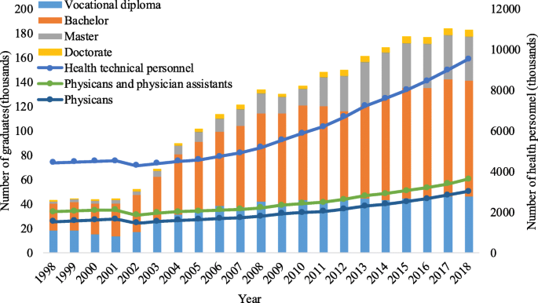
Figure 1. The number of doctors and medical trainees in China. Taken from Wang (2021).

Methodology
Here we review and analyse the existing medical education system in China, with particular focus on long-term educational support to the doctors. Multiple sources of data and materials, including those from government agencies, social organisations, academic research are integrated to critically evaluate the current long-term educational support provided to medical professionals and to reason our proposed recommendations.

Research results
Medical education in China is an examination-based hierarchical system. The system involves a five-year undergraduate with the final two years as clinical rotation. Three medical knowledge examinations (MKEs) occur in medical colleges during the period to screen eligible candidates for higher learning. Integrated Clinical Knowledge and Skill Examination (ICKSE) in the final year will be the ultimate test for undergraduate medical trainees to allow them to further advance into 3 year masters studies as resident doctors in one of the specialties, during which the trainee with satisfactory performance can be awarded a license. (Zheng et al., 2020) Ultimately, only less than half of the students can finally acquire the licences after all the screening tests.

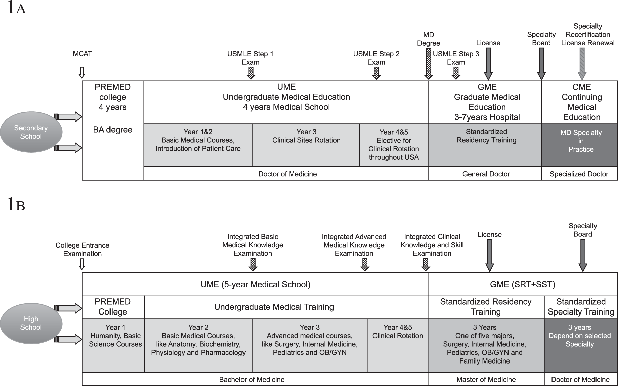

Figure 2. Physician training System under the Shanghai Model. Taken from Zheng et al. (2020)

The content of MKEs and ICKSE are defined by the National Health Commissions and are essentially based on medical textbooks published by the People's Medical Publishing House, which is responsible for updating the textbooks according to the latest medical knowledge and practices. However, due to the reason, both examinations do not require the students to seek and acquire additional medical knowledge for better medical practice. There are also no requirements for medical professional to pass the exams again to test whether they are eligible to use the updated medical knowledge, which could discourage innovations.

Continuous medical education varies according to institutions and are not typically obtainable for primary care sectors who are either overworked or under-funded for such resources. Most training of the kind is sponsored by pharmaceutical companies driven by the need to expand their product sales. Thus, such knowledge tends to only exist in certain hospitals in rich areas where the patients are willing to pay for better healthcare and can afford new medical products. Thus, wide regional gap in evidence-based medicine exists where doctors in remote regions are far less updated about latest best practices in medicine, though the government tries to publish Chinese-language guidelines to fill the gap (J.-Y. Wang & Jin, 2019).

Conclusions
- The current examination based licensing of the medical professionals does not require the doctors to update their knowledge, which reduces their desire for continuous medical education and their aspiration to do medical research.
- The company-doctor collaboration that centred in key hospitals in new drug promotion limits the ability of small clinics or independent physicians to update medical knowledge due to rareness of the resources.

Recommendations & implications
- Incorporate medical research designs and ethics in primary medical education and examinations instead of focusing only on clinical practice
- Integration of new knowledge in the form of regular literature review with peer reviews should be set as a way to evaluate doctors.
- The country should have a unified organisation to promote and update new medical knowledge to the doctors especially in remote regions
- Regional doctors exchanges programmes can be set up to promote knowledge spread in medical education and practice, where pharmaceutical companies can fund the programmes on a competitive basis to acquire more funding for such schemes

References
Tu, J. (2019). Practice of the Self: ‘Barefoot Doctors’ in Post-reform China BT - Health Care Transformation in Contemporary China : Moral Experience in a Socialist Neoliberal Polity (J. Tu (ed.); pp. 169–196). Springer Singapore. https://doi.org/10.1007/978-981-13-0788-1_7
Wang, J.-Y., & Jin, X.-J. (2019). Evidence-based medicine in China. Chronic Diseases and Translational Medicine, 5(1), 1–5. https://doi.org/10.1016/j.cdtm.2019.02.001
Wang, W. (2021). Medical education in china: progress in the past 70 years and a vision for the future. BMC Medical Education, 21(1), 453. https://doi.org/10.1186/s12909-021-02875-6
Wee, S.-L. (2018). China’s Health Care Crisis: Lines Before Dawn, Violence, and “No Trust.” New York Times, 2018. https://www.nytimes.com/2018/09/30/business/china-health-care-doctors.html
Zheng, J. C., Zhang, H., Wu, B., Tong, Z., Zhu, Y., Mitchell, M. S., Sun, X., Yang, Y., Zhang, K., Fang, L., & Adashi, E. (2020). Medical Education Reform in China: The Shanghai Medical Training Model. Journal of Graduate Medical Education, 12(6), 655–660. https://doi.org/10.4300/JGME-D-20-00069.1

